MODULE 3 ASSESSMENT
Scenario: Automating file backup and Reporting to the system. Create a shell script called "backup_manager.sh" that performs the following tasks incorporating the concepts suggested.
Requirements:
1. Command-line Arguments and Quoting:
The script must accept three arguments: Source directory: A directory containing files to back up. Backup directory: The destination where files will be backed up. File extension: A specific file extension to filter (e.g., .txt).
Example: ./backup_manager.sh "/home/user/source" "/backup" ".txt"
2. Globbing:
The script should use globbing to find all files in the source directory matching the provided file extension.
3. Export Statements:
Use export to set an environment variable BACKUP_COUNT, which tracks the total number of files backed up during the script execution.
4. Array Operations:
Store the list of files to be backed up in an array.
Print the names of these files along with their sizes before performing the backup.
5. Conditional Execution:
If the backup directory does not exist, create it. If creation fails, exit with an error.
If the source directory is empty or contains no files matching the extension, exit with a message.
If a file already exists in the backup directory with the same name, only overwrite it if it is older than the source file (compare timestamps).
6. Output Report:
After the backup, generate a summary report displaying:
Total files processed.
Total size of files backed up.
The path to the backup directory.
The report should be saved in the backup directory as backup_report.log.

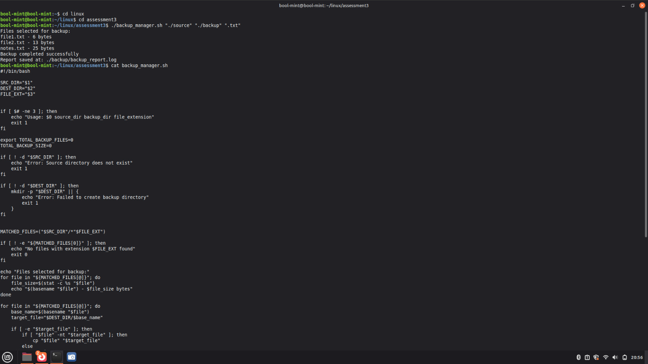
#!/bin/bash

SRC_DIR="$1"
DEST_DIR="$2"
FILE_EXT="$3"

if [ $# -ne 3 ]; then
echo "Usage: $0 source_dir backup_dir file_extension"
exit 1
fi

export TOTAL_BACKUP_FILES=0
TOTAL_BACKUP_SIZE=0

if [ ! -d "$SRC_DIR" ]; then
echo "Error: Source directory does not exist"
exit 1
fi

if [ ! -d "$DEST_DIR" ]; then
mkdir -p "$DEST_DIR" || {
echo "Error: Failed to create backup directory"
exit 1
}
fi

MATCHED_FILES=("$SRC_DIR"/*"$FILE_EXT")

if [ ! -e "${MATCHED_FILES[0]}" ]; then
echo "No files with extension $FILE_EXT found"
exit 0
fi

echo "Files selected for backup:"
for file in "${MATCHED_FILES[@]}"; do
file_size=$(stat -c %s "$file")
echo "$(basename "$file") - $file_size bytes"
done

for file in "${MATCHED_FILES[@]}"; do
base_name=$(basename "$file")
target_file="$DEST_DIR/$base_name"

if [ -e "$target_file" ]; then
if [ "$file" -nt "$target_file" ]; then
cp "$file" "$target_file"
else
continue
fi
else
cp "$file" "$target_file"
fi

size_bytes=$(stat -c %s "$file")
TOTAL_BACKUP_SIZE=$((TOTAL_BACKUP_SIZE + size_bytes))
TOTAL_BACKUP_FILES=$((TOTAL_BACKUP_FILES + 1))
done

export TOTAL_BACKUP_FILES

REPORT_PATH="$DEST_DIR/backup_report.log"

{
echo "Backup Summary Report"

echo "Total files processed : $TOTAL_BACKUP_FILES"
echo "Total size backed up : $TOTAL_BACKUP_SIZE bytes"
echo "Backup directory : $DEST_DIR"
echo "Date : $(date)"
} > "$REPORT_PATH"

echo "Backup completed successfully"
echo "Report saved at: $REPORT_PATH"

